ASSIGNMENT - DAY 3

1. **Fibonacci series using recursion**

class Solution {

public int fib(int n) { if(n==0||n==1){

return n;

}

return fib(n-1) + fib(n-2);

}

}

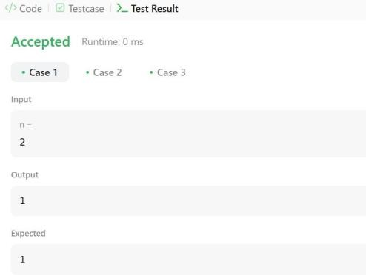

1. **Factorial of number using recursion**

class Solution {

static int factorial(int n) { int result =1;

for(int i=1;i<=n;i++){

result = n*factorial(n-1);

}

return result;

}

}

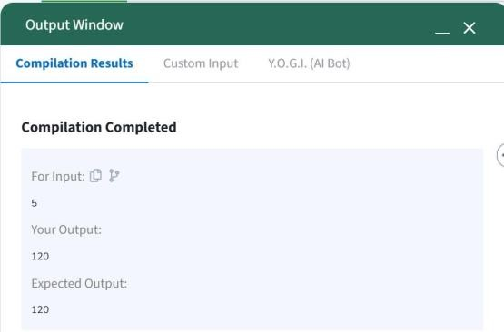

1. **Sum of array elements using recursion**

class Solution {

int sum(int arr[]) { int sum = 0;

for(int i=0;i<arr.length;i++){ sum = sum + arr[i];

}

return sum;

}

}

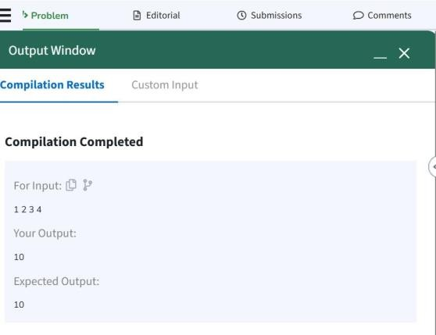

1. **To find reverse of string using recursion**

import java.io.*;

import java.util.Scanner;

class Solution {

public static void main(String[] args) {

String s = "Geeks"; String r = "";

char ch;

for (int i = 0; i < s.length(); i++) { ch = s.charAt(i);

r = ch + r;

}

System.out.println(r);

}

}

Output: skeeG

1. **Sum of natural number using recursion**

import java.util.*; import java.lang.*;

class Solution

{

public static int recurSum(int n)

{

if (n <= 1)

return n;

return n + recurSum(n - 1);

}

public static void main(String args[])

{

int n = 5; System.out.println(recurSum(n));

}

}

Output : 15